It is intended to be a very simple approach to derive landscape connectivity metrics. Many of these metrics come from the interpretation of landscape as graphs.

Additionally, it also provides a function to **prioritize landscape patches** based on their contribution to the overall landscape connectivity. For now this function works only with the **Integral Index of connectivity**

Here’s a brief tutorial!

First **install** the package:

#load package from CRAN

#install.packages("lconnect")

library(devtools)

Then, **upload the landscape shapefile** …

#Load data

vec_path <- system.file("extdata/vec_projected.shp", package = "lconnect")

…and create a ‘**lconnect’ class object**:

#upload landscape

land <- upload_land(vec_path, habitat = 1, max_dist = 500)

class(land)

## [1] "lconnect"

And now, let’s **plot** it:

plot(land, main="Landscape clusters")

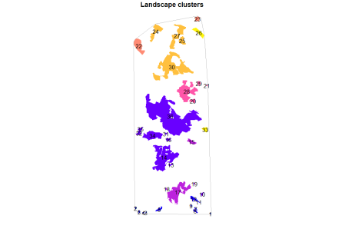

If we wish we can derive **patch importance** (the contribution of each individual patch to the overall connectivity):

land1 <- patch_imp(land, metric="IIC")

## [1] 0.0000000 0.0000000 0.0000000 0.0000000 0.0000000 0.1039501

## [7] 0.1039501 0.0000000 0.1039501 0.0000000 0.0000000 0.1039501

## [13] 0.3118503 21.9334719 0.0000000 15.5925156 2.5987526 0.1039501

## [19] 0.1039501 0.2079002 0.0000000 0.0000000 0.0000000 0.0000000

## [25] 0.9355509 0.0000000 14.2411642 2.9106029 0.2079002 12.9937630

## [31] 0.3118503 0.7276507 0.0000000 7.5883576 0.5197505 70.2702703

class(land1)

Which produces an **object of the class ‘pimp’**:

## [1] "pimp"

And, finally, we can also plot the **relative contribution of each patch** to the landscape connectivity:

plot(land1, main="Patch prioritization (%)")

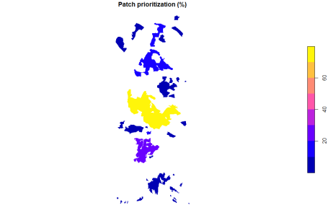

And that’s it!